Endocrine System
- What are the primary functions of the endocrine system?

- The two components of the endocrine system are __________________ and _______________________.
- Endocrine glands release ___________ that circulate throughout the __________ to specific ______ causing a _______________ response. Endocrine glands are ________. They release products directly into the ________________.
- Imbalances in the endocrine system can ____________ function and cause ____________. The body uses positive and negative feedback loops to restore ________________ by turning on/off the production of ______________. Define and give an example of each type of feedback loop.

- Hormones are also known as...
- What are the three classes of hormones?

- Hormones are ___________ chains. They have a ___________________ relationship with their receptors.
- There are 3 modes of hormone transmission. What are they? How far does each one have to travel?

- What is half-life in reference to hormones?

- Hormones have two classes of biochemical structures.
  - ____________ hormones (_______)
    - Cholesterol-based (hydro_________)
    - Faster response due to _______________________ into cells
    - _________ half-life
    - Examples
      - Sex steroids:

  - ____________ hormones (_________)
    - __________________ derived (hydro________)
    - Bind to __________ on the outside of a cell. Then they utilize a 2nd messenger pathway which kicks off a ___________________ inside of the cell.
    - _________ half-life
    - Examples

- The ___________________ serves as the interface between the ____________ and endocrine systems. The three hormones associated with it are _____________ (nervous system related), __________________________, and _____________________. ________________ hormones stimulate other _______________ to be _______________.

- The pituitary gland is split into the _________ and ___________ pituitary glands. What hormones are associated with each part?

- How does chronic stress affect an animal in relation to hormones and body function?

- The thyroid gland’s function is _______________. It helps to regulate __________ use and _____ generation. It secretes both peptide-based and amine-based hormones. What are examples of each type?

- The parathyroid gland has both internal and external glands. The parathyroid gland releases ______________________________. What does this hormone do?

- The ___________ glands sit on top of the kidneys. What hormones are released from the cortex and what do they do? Which hormones are released by the medulla and what part of the nervous system do they control?

- Hormones work together to maintain _________________.

- The ____________ as sex dependent structures that produce hormones which affect the tissues known as ___________________. The gonads are the primary producers of _______________ which affect sex _________________. What are the male and female gonads and what hormones do they produce?

- The ______________ is both an endocrine and exocrine gland. It produces three types of hormones. What are they and what do they do?

- Explain how blood glucose is regulated.

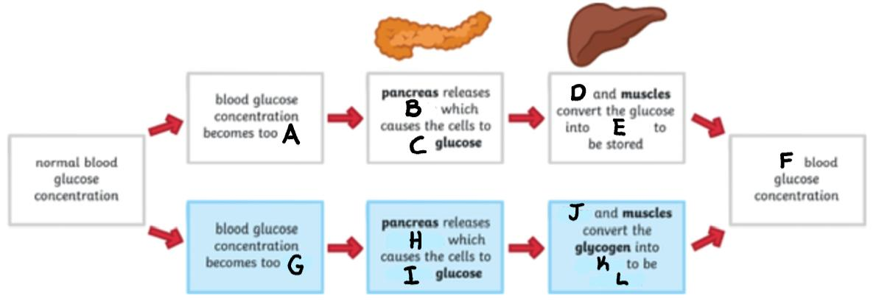
- Common endocrine disorders
  - ____________ Insulin
  - Cushing’s Disease _________________
  - ____________ Thyroid

