Skeletal Labeling and Review
- What are the different types of bones?

- ________________ bones are formed through endochondrial ossification.
- ________________ bones are formed through intramembranous ossification.
- What are the bones of the axial skeleton?

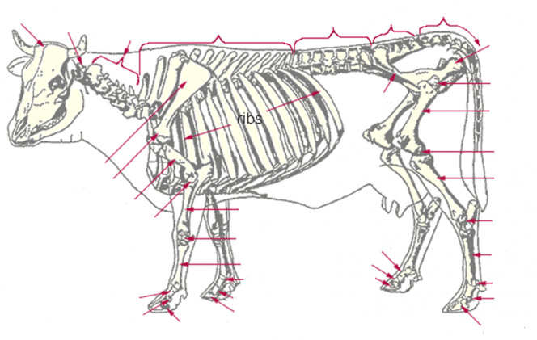
- Label the sections of vertebrae.

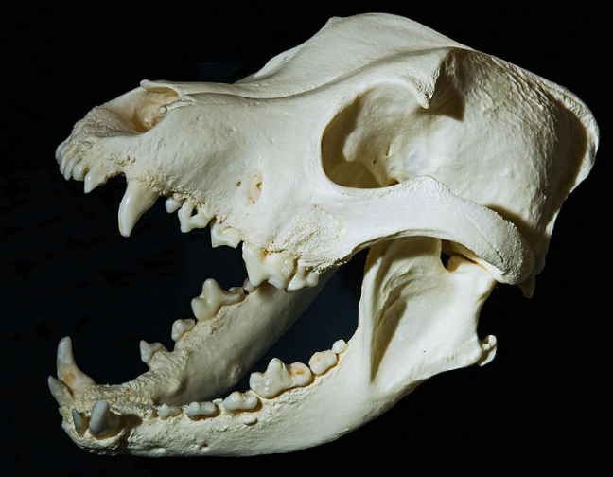
- Label the maxilla and mandible.
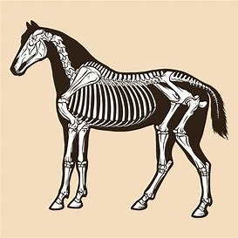
- Label the bones of the thoracic and pelvic limbs.

